7.66: Denote the distance the truck moves up the ramp by x. 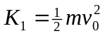, 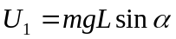, 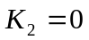, 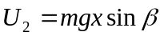 and 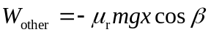. From 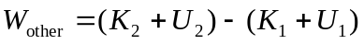, and solving for x,
